Promotional Toolkit
Reimagine Arkansas Workforce Project
Thank you, partners, for helping the state and our institution share information about career training available to Arkansans at no cost to them if they qualify. Free training is provided by the Reimagine Arkansas Workforce Project, which is funded by a federal grant.
We want to make it easy for you to share this information. Below are ready-to-use communication tools for you to send to your staff and for your staff to send to their clients. Details about the grant, training programs, and an application form are available at https://training.uark.edu/reimagine
How You Can Share
Print and post the 8.5” X 11” Reimagine Workforce posters attached to the email:
- Poster A – A printable Reimagine Workforce PDF for your staff in their workspaces
- Poster B – A printable Reimagine Workforce PDF for your clients in your facility
Copy and paste the words provided below in this toolkit:
- Email from Leaders to Staff – An email message you can copy, adjust, and send to your staff. Also include the posters for staff and clients! 3
- Email for Staff to Send to Clients 4
- Printed Program Announcement – Words for a printed program, including faith- and service-based organizations 5
- Social Media Copy - Words and an image for a Facebook or Twitter Post 6

If you need printed materials mailed to you, please let us know what and how many you need by sending a message to training@uark.edu.
We thank you for sharing this opportunity for Arkansans who need training to enter or thrive in the workforce.
CONTACT
Professional and Workforce Development at the University of Arkansas
training@uark.edu
855-402-3300 (toll free)
479-464-5024
Email from Leaders to Staff Members of Agencies and Organizations (copy and paste)
Hello, (staff member name),
It takes a lot of resources to help strengthen and improve our local communities. You now have another tool to share. The Reimagine Arkansas Workforce Project at the University of Arkansas can provide free, short-term, online job training for Arkansans who qualify. Funding for in-demand training, available thanks to a grant through the Arkansas Division of Workforce Services, can help Arkansans enter or thrive in the workplace.

This free job training is an excellent opportunity for those who want to invest their time in working toward a better future. Visit the U of A Reimagine Arkansas Workforce Project website to access an online form your clients can use to apply for federal funding from the U.S. Department of Education.

The project offers:
- 15 career fields
- A simple, online application for grant eligibility
- Training at no cost to those who qualify
- The ability to create a free SmartResume® account with IDatafy to share training completions with employers searching for talent
Who Should Apply?
- Arkansas Residents (or residents of a neighboring state who work in Arkansas)
- 18 years of age or older
- Eligible to work in the U.S.
- If male, registered for selective service or exempt (can register before applying)
The U.S. Department of Education awarded a grant worth over $13 million to the Arkansas Workforce Development Board and the Arkansas Division of Workforce Services to fund the Reimagine Arkansas Workforce Project. This state-wide coordinated effort is intended to benefit Arkansans who have been economically impacted by the COVID-19 pandemic. Project partners include state agencies, U of A Global Campus Professional and Workforce Development, Shorter College, and IDatafy LLC.

Printed materials are available.

CONTACT
Professional and Workforce Development
University of Arkansas
training@uark.edu
855-402-3300 (toll free)
479-464-5024

Email for Staff to Send to Clients on Organization/Agency Lists (people who need training, copy and paste)
Hello, (client name),
Are you ready to take the next step in building a better life for you and your family? You can gain skills that employers want through free online job training. This training is funded through the Arkansas Division of Workforce Services and provided by the University of Arkansas.
These online training programs provide skills to help you enter, re-enter, or advance in the workplace, and you can choose training from 14 in-demand career fields. Visit the U of A Reimagine Arkansas Workforce Project website to see options and apply for training at no cost to you. Training is an investment in yourself, your family, and your future career.
Who Should Apply?
- Arkansas Residents (or residents of a neighboring state who work in Arkansas)
- 18 years of age or older
- Eligible to work in the U.S.
- If male, registered for selective service or exempt (can register before applying)
Visit the U of A Reimagine Arkansas Workforce Project website to learn more. Find out what information and documents you will need before starting the online application form, and then click the red button to APPLY FOR FUNDING.
This program is for Arkansans who are unemployed, underemployed, are new to the workforce and/or have no work history, are a member of an underrepresented population, receive public assistance, reside in rural areas, are a veteran, are the spouse of a veteran, are experiencing homelessness, are 55 years or age or older, previously incarcerated, have been paroled, or are on probation. If you are in one of these groups, you are encouraged to apply.
If you have questions, contact the University of Arkansas Professional and Workforce Development staff at training@uark.edu or call 855-402-3300 (toll free).

Job training programs are an investment in yourself and your future career, and we encourage you to explore this option.

Kind Regards,
(Your name)
(Your organization)

Printed Program Announcement (faith- and service-based organizations, copy and paste)
Invest Your Time to Gain Job Skills That Are In Demand in the Workplace
For a limited time, the University of Arkansas is offering free, online job training for Arkansans who need new skills to enter or thrive in the workplace and who meet grant qualifications. Get details and access an online application through the Reimagine Arkansas Workforce Project at training.uark.edu/reimagine
Who Should Apply?
- Arkansas Residents (or residents of a neighboring state who work in Arkansas)
- 18 years of age or older
- Eligible to work in the U.S.
- If male, registered for selective service or exempt (can register before applying)
Contact the U of A Professional and Workforce Development staff at training@uark.edu or call 855-402-3300 (toll free) or 479-464-5024. We can help guide you on a path to a new career.

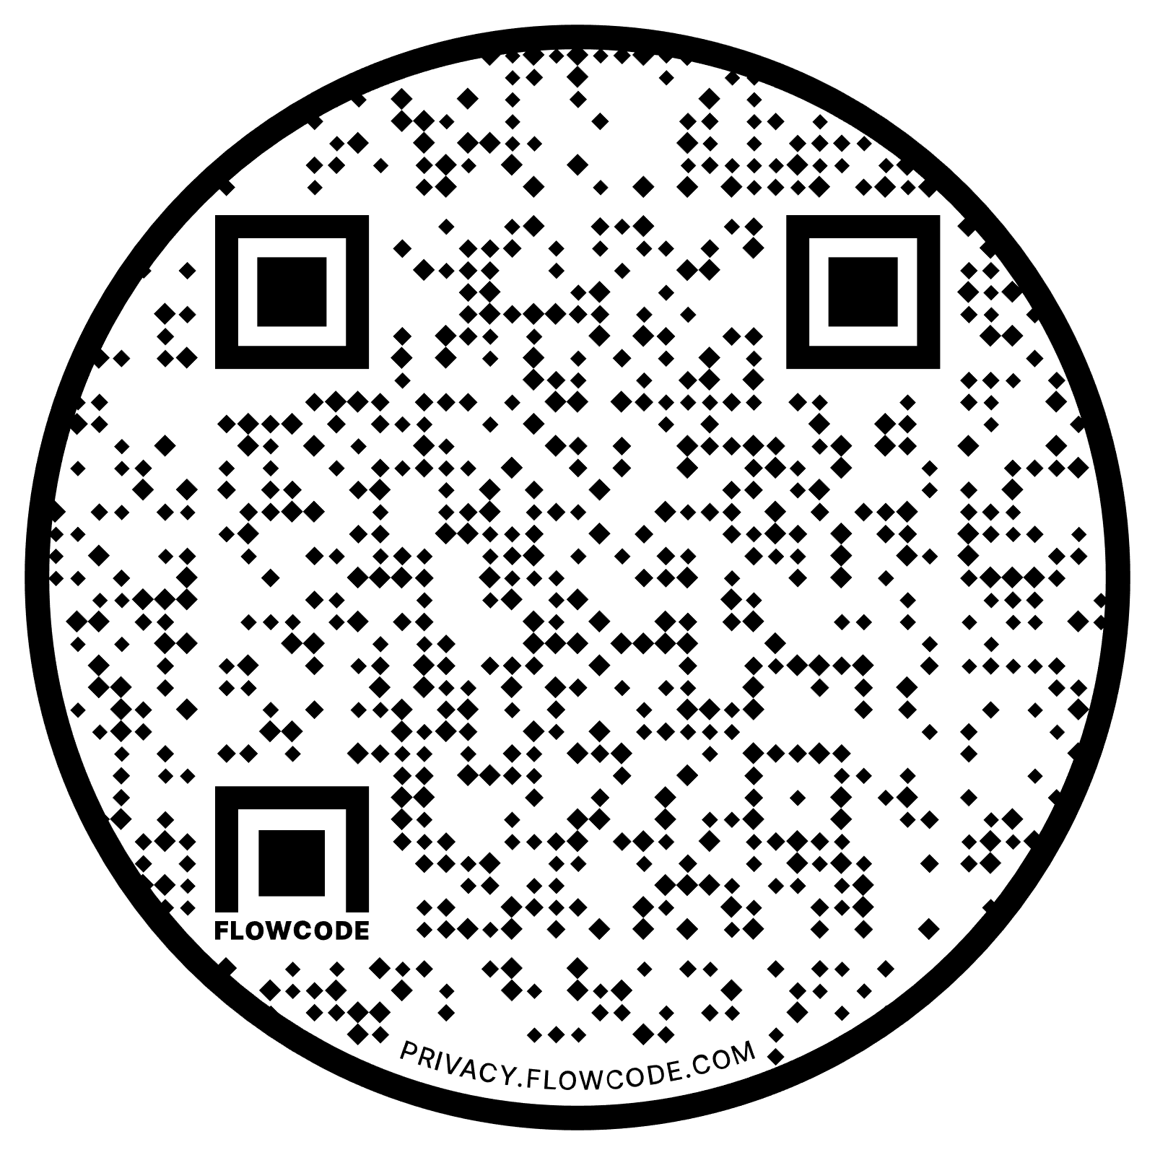

The Reimagine Arkansas Workforce Project is for Arkansans who are unemployed, underemployed, are new to the workforce and/or have no work history, are a member of an underrepresented population, receive public assistance, reside in rural areas, are a veteran, are the spouse of a veteran, are homeless, are 55 years or age or older, previously incarcerated, have been paroled, or are on probation. Arkansans who are a part of any one of these groups or who are experiencing any one of these situations are encouraged to apply.
Training is available in 15 career fields, including business, construction, health care and technology. The U.S. Department of Education awarded a grant to the Arkansas Division of Workforce Services to provide this training. The state is working with the University of Arkansas, Shorter College, and IDatafy. The grant ends in September 2023.

Social Media Copy (words)
Facebook and/or Instagram (copy and paste)
Invest your time in free job training to help you enter or thrive in the workplace. The University of Arkansas #training can help you gain in-demand skills in one of 15 career fields, including business, construction, health care and technology. Apply online for Reimagine Arkansas Workforce Project funding to cover training costs at https://training.uark.edu/reimagine.
Twitter (copy and paste)
Reimagine your career by gaining skills employers want. #Training from the University of Arkansas can help you get the skills to enter or thrive in the workplace. Apply for training through the Reimagine Arkansas Workforce Project at https://training.uark.edu/reimagine

Facebook or Twitter Image (save as an image/picture to your computer or download from the tool kit page)
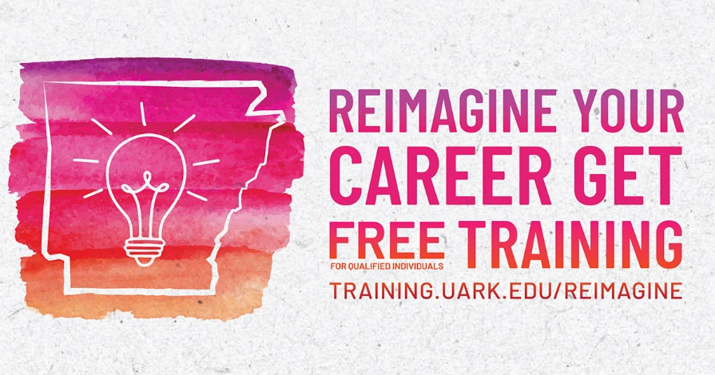
Instagram Image (save as an image/picture to your computer or download from the tool kit page)
